Worksheet—Defining Chartism

Examine the sources included with this worksheet. Consider how they help you answer the key question:
What was Chartism?
Use this table to record your ideas
Source 1: Handbook of the People’s Charter Union, 1848

Source 2: Newspaper accounts of riots in Preston, 1842

Source 3:
Article on trouble in Manchester, 1842
Source 4: Illustrations of a meeting of Chartists on Kennington Common, 1848

1) Now, define Chartism in your own words.

2) Do you think these documents are enough to show you the full picture?

3) Where might you go to find out more evidence?

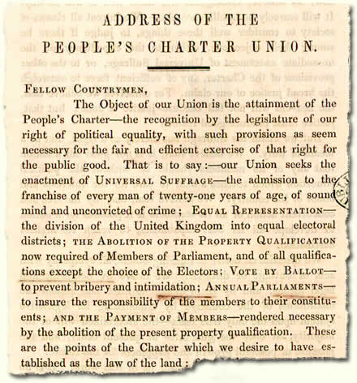

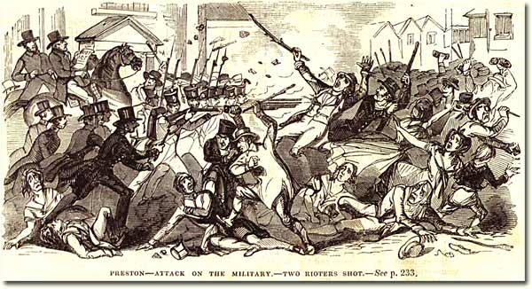

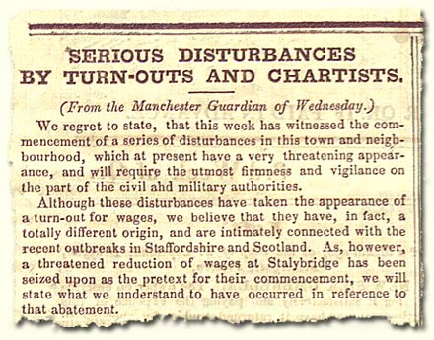

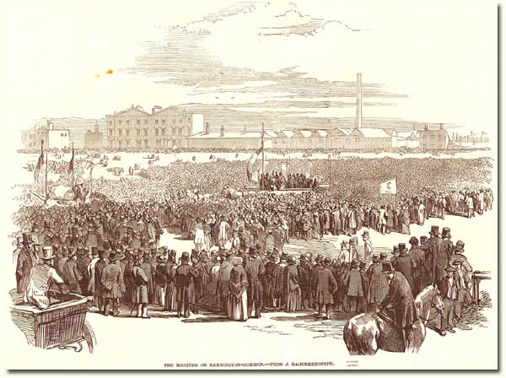

Worksheet—Peterloo Massacre

Examine the sources in this gallery. Consider how they help you answer the key question:

What happened at St. Peter’s Fields? Whose fault was it?

Use this table to record your ideas
Source 1:
Letter from the Home Secretary,
4 August 1918

Source 2:
Engraving of the events at St. Peter’s Fields, 1819

Source 3:
Letter from a Lancashire magistrate,
16 August 1819

Source 4:
Letter on the conduct of the Manchester magistrates,
23 August 1819

1) What happened at St. Peter’s Fields? Whose fault was it?

2) Do you think these documents are enough to show you the full picture?

3) Where might you go to find out more evidence?

