MR. C’S HUMAN EVOLUTION READING/STUDY GUIDE
12.0 Introduction
All humans are members of the species Homo sapiens (Latin = "man who is wise"). Today, man may be considered a dominant species on the earth due to his:
(1) Accumulation of achievements (e.g., language, tools and methods developed to feed and, shelter, organization in groups, achievements in arts, commerce and science); and
(2) Cultural and biological evolution due to biological attributes or characters such as (a) excellent stereoscopic vision(b), a large brain with a unique capacity for learning and reasoning. (c) hands that can grasp and manipulate objects. (d) upright bipedal (two-footed) posture. (e) specialized teeth for an omnivorous diet. (f) presence of the foramen magnum below the cranium so that the head can be moved about freely. These biological characteristics appeared gradually over 70-80 million years of primate evolution.
Homo sapiens belongs to the mammalian Order-Primates which also includes tree shrews, tarsiers, lemurs, lorries, monkeys and apes. The primate order is divided into :
(1) Sub-order - Prosimi (Pro = almost, Simians-apes) e.g. lemurs, lorries, tarsiers, shrews.
(2) Sub-order - Anthropoidea (Anthrop = man, oid = like) e.g. monkeys, apes, humans are closely related species are placed in super family - Hominoidea (man-like). Present and past Hominoids having man-like features are placed in family - hominidae. There were at least two species of the genus Homo (Homo habilis and Homo erectus), but the only living survivor is Homo Sapiens.
We place ourselves in the order Primate because we resemble the Primates more than any other animal. Before we get to know our ancestors, the major groups of primates (Figure 12.1 A) related distinctly to human evolution are :
Tree shrews - which resemble those mammals from which the primates arose.
Tarsiers - with long tails, long hind limbs, stereoscopic vision, improved grip form, the most advanced prosimians because they are like the monkeys.
Lorises and Lemurs - which colonized early in their evolutionary history, until humans arrived some two thousand years ago.
Monkeys - can walk upright, they are relatively intelligent, live in groups, females care for the young, they have larger brains than prosimians, and have stereoscopic and color vision.
Apes - are the closest kin to humans in size, form, physiology and behavior. They have bigger brains, and brachian style of locomotion (swing by their arms as shown in figure 12.1B) which is related to the evolution of an erect body posture and elongation of arms. Apes and humans constitute the hominoids. Besides humans, gibbons, orangutans, chimpanzees and gorillas are the only living forms of hominoids. Gibbons and orangutans are arboreal brachiators. Orangutans, chimpanzees and gorillas, when on ground walk on all fours, supporting their weight on their fists, (called - knuckle walkers). Chimpanzees and gorillas are more intelligent, can use simple tools and have the ability to learn sign language.
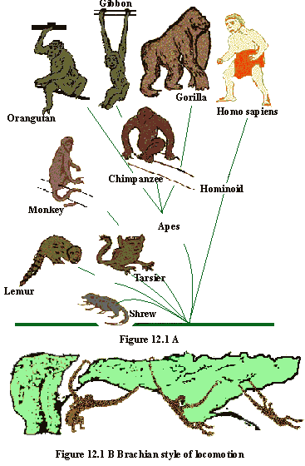
Studies of DNA sequences have shown that humans are more closely related to chimpanzees than to any other primates. Human and chimp DNA are 99 percent identical; but that is not to say that the humans have descended from fossil chimps. Fossil records shows that humans and apes have both descended from a common ancestor, or such genera as Dryopithecus, Ramapithecus and Sivapithecus which lived in Africa and Asia. A brief account of various genera related with human evolution is adressed in section 12.3.
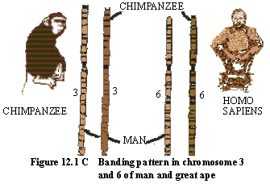
12.1 Palaeontological Evidences -Our Ancestors
Fossil

records of human evolution is quite incomplete and we have much to learn yet. In 1863, T.A. Huxley explained human evolution in his book Man’s Place in Nature. In 1871, Charles Darwin published his ideas of human evolution in the book The Descent of Man. Later on many attempts have been made to find the missing link between man and ape in the form of an original creature or its fossil. Eugene Dubo unearthed the first fossil record of an ancestor of man in the form of a small part of skull and jaw bone. Between 1920 to 1930 many human-like fossils were found in China called "Peking Man" or Sinanthropus. But these fossil evidences do not form a neat chain of links leading from ancient ape to the modern human.
It appears from the fossil evidence, that human and apes have both descended from a common ancestor, called Dryopithecus, that lived over 20 million years ago. At about the same time the first human-like fossils were found in India and Africa in the form of such primate genera as Ramapithecus and Sivapithecus. The arrangement of teeth was like our own, indicating that Ramapithecus was one of our ancestors. The next known genus Australopithecus africanus (1.5 to 3 millions years ago) appeared in Africa. It had a rounded skull with a brain capacity of 450 to 700 cm3 (compared to 1000 to 2000 cm3 for humans), apparently walked upright, and was about 5 feet tall.
Some controversy still exists about these human ancestors and the gaps in evolutionary sequence, because the relevant fossils are rare, the remains did not survive until now, or have not yet been found.
There is less controversy over the more recent stages of human evolution. The fossils are more abundant and there are fewer gaps. They show that Homo erectus, the first known member of our genus, followed Australpithecus. Some 2 to 3 million years ago Homo erectus emerged as an erect, bipedal creature, with a receding forehead and human-like skeleton. Remains of H. erectus have been found in Africa, South East Asia and China.
The first fossil that belongs to our own species, Homo sapiens, appeared as recently as 100,000 to 40,000 years ago, and resembles us so closely that we call it human (Fig. 12.2). Homo sapiens survived as a result of erect bipedal posture, increased manual dexterity, feet suited for walking and running, and better developed creative brains.
Archeological records of human evolution indicate that early humans started out as small bands of hunters who killed animals for food and supplemented this with foraged and gathered items. The hunt-gatherer cultures allowed humans to exploit agriculture, about 10,000 years ago. Humans began to farm seriously around 8,000 BC and there was full fledged agriculture in many places just after 4000 BC. The agriculture allowed establishment of stable populations, and the development of technology permitted the survival and growth of human population.
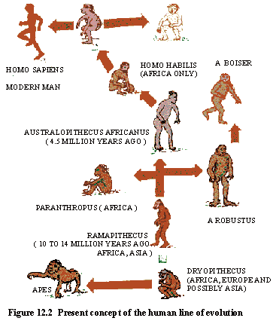

12.2 Ancestral forms of Homo sapiens
As mentioned earlier, the palentological (fossil) record for human evolution is not continuous. Ever since the theory of evolution become scientifically acceptable, biologists and anthropologists have been trying to find the ‘missing link’, the species that would bridge the gap between humans and the great apes which are the closest living relatives of humans. The fossils collected from various regions indicate possible trends in human evolution. Some important ancestral forms of Homo sapiens are described below.
(1) Dryopithecus
It appears from fossil evidence, that humans and apes (Hominids) have both descended from a common ancestor, called Dryopithecus, that lived 20 million years ago (Miocene epoch). The first Dryopithecus fossils were found in 1930 on an island in Africa’s lake Victoria by Dr. Lewis Leakey. Later on they were also found in Africa, N. India, China and Europe. The Dryopithecus were first described as Sivapithecus, Proconsul and Ramapithecus. Dryopithecus were contemporary to another genus, Pliopithecus. These appear of be ancestors to apes and humans. Important anthropoid characters of Dryopithecus included a somewhat flattened face, a shortened jaw, enlarged incisors (typical of apes, but not human), arms and the legs of the same length and must have assumed a semi-erect posture on the ground and were more bipedal than the other apes.
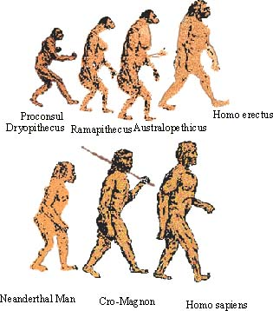
Figure 12.3 Human Evolution
(2) Australopethicus
Australopithecus africans represents the next known step in human evolution. The fossil remains from Africa belonged to early Pleistocene era (1.2 - 3 million years ago) and named by Raymond Dart in 1924. It weighed 40-60 pounds, bipedal form of primates, walked in an entirely erect posture, a distinct lumbar curve and had human-like teeth. The dental arch was a smoothly rounded parabola. However, Australopithecines had jaws and teeth larger than those of modern man. It had an ape-brain (capacity 450-700 cc.) rather than a human brain.
They were living in groups assumed to be using tools (made by chipping pebbles) since the fossils are often found with piles of bones of hares, birds, baboons. This indicates that they were true hunter scavengers, who actually hunted animals they ate. Another form of hominid, Australopithecus robustus, appeared later, weighed 150-200 pounds, walked erect and had a brain size similar to that of the ape.
Another type of hominid creature lived in the place and period as Australopithecus and was also bipedal, but had a larger brain and used tools. It was placed in genus Homo - its full name is Homo habilis (habilis = mentally skillful).
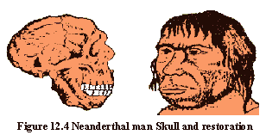
(3) Homo erectus
Remains of Homo erectus have been found in Africa, South East Asia and China and belonged to a later part of Pleistocene period. It lived from over 2 million years ago up to about 300,000 years ago. It contains specimens such as Java man (Pithecanthropus erectus), and Peking man (Sinathropus pekinensis), classified together as members of the species Homo erectus.
Homo erectus had a receding forehead, heavy jaws and prominent bony brows. It was more than 5 feet tall, weighed 70 kg. had a human like skeleton and apparently walked upright as indicated by the position of the foramen magnum in their skulls - which is same as in modern humans. (Refer to figure 12.7). The cranial capacity was about 970 cm3 . Homo erectus lived in caves and had more-or-less permanent home bases, made a fire and brought it indoors to cook food or split stones.
This stage of human evolution is correlated with colonization and migration to colder areas (Europe, China) and communal living in caves. The pre-human brain of Homo erectus could produce social and technological solutions - such as fire, clothing, stored food etc. to survive cold winters.
4) Homo neanderthalensis (Neanderthal Man)
This first specimen of this kind was discovered in Neander valley of Germany in 1856. These early humans existed some 150,000 years ago and were widespread in Europe, Asia and North Africa. They closely resembled humans. This human species was short, stocky, with heavy jaws, a receding chin, with an erect stance and the hands used like man. The brain was as big as the modern man and with almost same cranial capacity (1450 cm3 ). They became extinct about 25,000 years ago probably in competition with Homo sapiens. Another theory is that they interbred with Homo sapiens and their distinctive characters disappeared into the common human gene pool.
Culturally, Neanderthals were more advanced than the Homo erectus. They lived in caves, made simple tools, dug pits to trap large animals and were even cannibalistic sometimes.
(5) The Cro-Magnons
Fossils of men and women were discovered in France in 1868. They were very much like the modern man, therefore, Cro-Magnon man has been considered as a sub-species of Homo sapiens. The Cro-Magnons were about 150 cm tall, with a rounded forehead, distinct chin, narrow nose and broad face. They walked erect and were swift footed. The cranial capacity was 1650 cm3. They lived in caves, were experts at hunting, painting and became the farmers and metal workers of Egypt, philosophers of Greece, Indians of the America and Eskimos of the Arctic. They buried their dead according to their customs. The Cro-Magnons became extinct about 20,000 years ago and were more advanced than the Neanderthals.
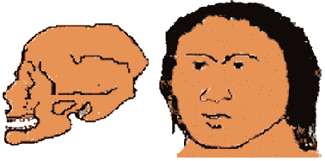
Figure 12.5 Cro-Magnon Man: Skull and restoration
As the Cro-Magnons spread over the Earth; the environments exerted selective pressure. This resulted in different groups of people now called races, which differ in their skin color, predominant blood type, form, hair color, body features and size. Depending upon where one draws the lines we can count about 6 to 34 modern races. Further evolution of modern man after Cro-Magnon’s was more of culture than structure.
(6) Homo sapiens
They first appeared less than 1,00,000 years ago. During the evolution of Homo sapiens, we have seen that our ancestors changed from ape to apelike to human-like to human, and thus changed in several ways. For example
(1) They changed from four-legged to two-legged posture, became erect and bipedal.
(2) The feet lost their hand like features and became suited for upright walking and running.
(3) The hands became more dexterous, free to manipulate, the thumb became opposable with precision and power grip. (Figure 12.6)
(4) The brains grew larger, and a more creative intelligence developed.
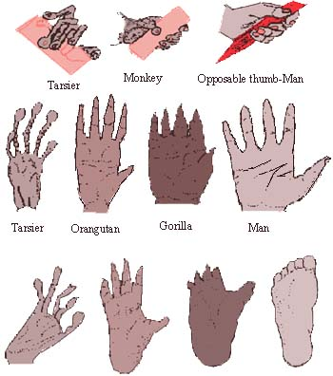
Figure 12.6 Hands and feet of tarsier, orangutan, gorilla and man
The following evolutionary changes are seen in man:
1. Erect posture.
2. Balancing of head on neck.
3. Vertebral column showing four curvatures. (Figure 12.7 A)
4. Forelimbs shorter than hind limbs.
5. Small jaw and teeth.
6. The dental arches changed shape, all the teeth moved closer together and the canine teeth became shorter (Figure 12.7 B).
7. Man’s foot develop into a sturdy support with complete base.
8. The toes shortened and the big toe moved into line with others. The foot became arched.
9. Apes have long, slanting hip girdle. Man’s pelvis is short, wide and vertical. It permits erect posture and frees hands for manipulation. (Figure 12.7C)
10. Brain expansion (increased cranial cavity, complex cerebellum and cerebrum) and the use of tools are associated with the human evolution (12.D & E).
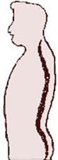
Greater curvature of spine in human
Figure 12.7A
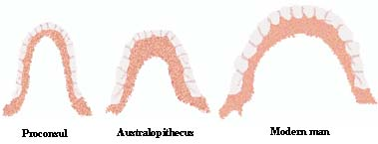
Figure 12.7B Change in shape of dental arches
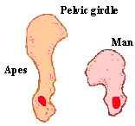
Figure 12.7C Pelvic girdle
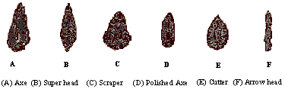
Figure 12.7D
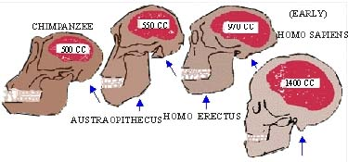

Figure 12.7E Changes in the proportion of the skull from ape to human. Note position of foramen magnum(arrows)
Thus, we find that we are basically the same as our Cro-Magnon ancestors, who lived about 35,000 years ago.
SUMMARY
(1) Human beings, Homo sapiens, are primates whose ancestors were arboreal during the mesozoic era.
(2) The arboreal characters were highly developed in anthropoid apes, which probably had a common ancestor with human in species like Dryopithecus during the Pliocene.
(3) The two groups, apes and human ancestors diverged and the human ancestors gradually adapted for erect, bipedal locomotion on the open plants.
(4) Further evolution of man revolved around the use of brain and hands to collect food, to make tools for hunting, collection and storing of food, colonization, agriculture and finally to make fires and clothes which permitted hominids to spread from their original home in Africa.
(5) A common ancestry for a great apes and man is based on similarities in DNA content, chromosome number and banding patterns of chromosomes.
**********

