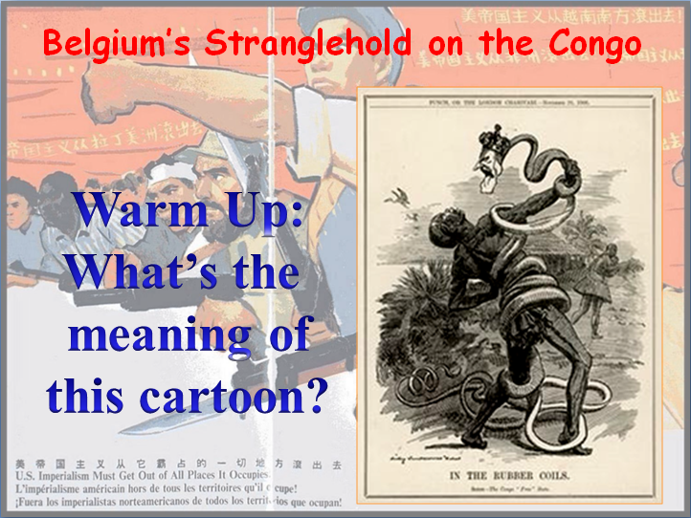
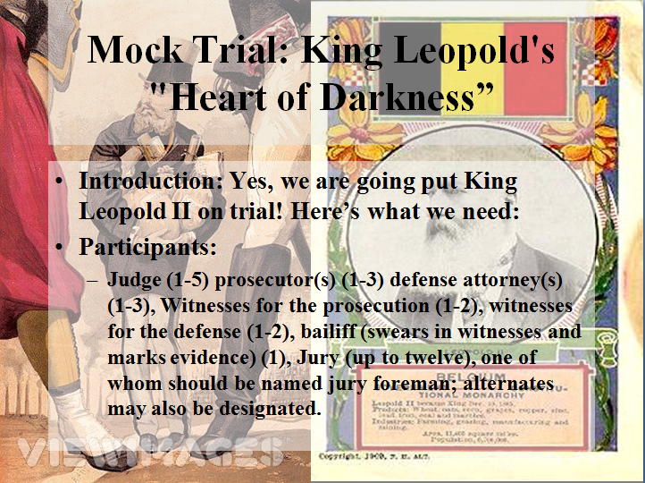
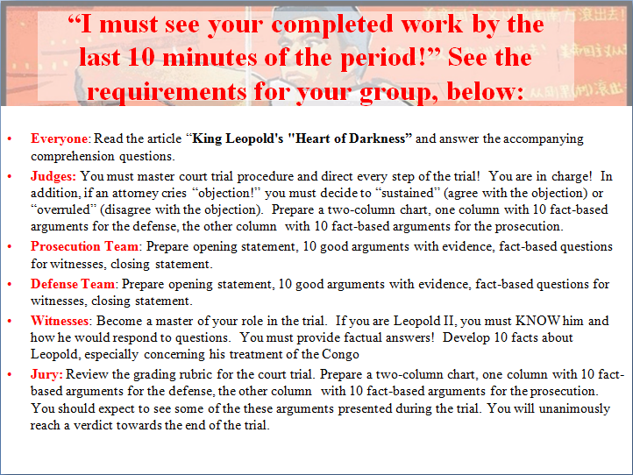
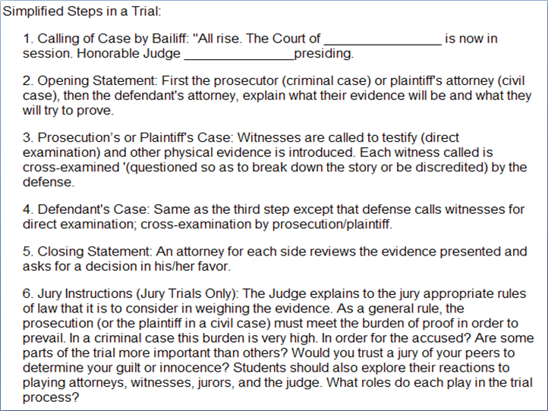
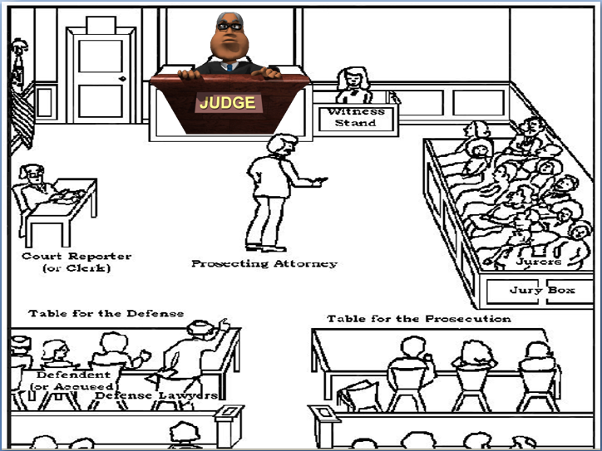
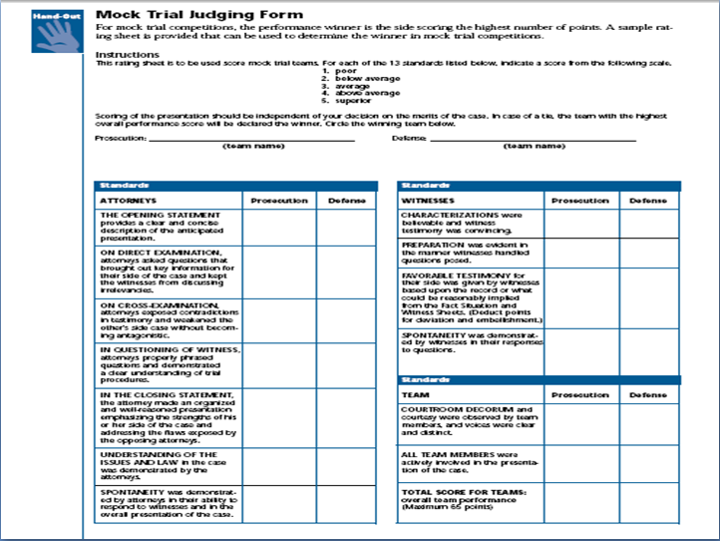
King Leopold's "Heart of Darkness"
In 1885, King Leopold II of Belgium gained a vast area in central Africa as his personal possession. His greed and the system of forced labor he imposed there prompted the first human rights movement of the 20th century.
Five years after most European nations and the United States had granted colonial status to King Leopold's "Congo Free State," a young merchant seaman traveled up the Congo River in a steamboat. Joseph Conrad was one of the first outsiders to witness and later write about the horrors committed by Leopold's regime in its greedy pursuit of Congo ivory and wild rubber.
In 1902, Conrad published his novel, The Heart of Darkness. In this fictional story, a man much like himself travels up a river into a rain forest where he meets a European ivory trader named Kurtz. The methods Kurtz uses to force the native people to bring him the ivory elephant tusks is symbolized by his guns and a ring of poles around his house. On top of each pole is a human head.
Conrad attempted to show that the "heart of darkness" lay deep within the Europeans who exploited the land and people of the Congo. But the full story of the Congo Free State not only involves the evil acts committed there, but also the campaign to expose them to world public opinion.
Exploring the Congo
Ten years before Columbus reached America, the Portuguese entered the mouth of Africa's Congo, one of the great rivers of the world. At first, good relations developed between the Portuguese and the several million inhabitants of the Kingdom of the Congo. The Portuguese didn't want to conquer or colonize the Congo. They only hoped to trade and to introduce Christianity.
The Kingdom of the Congo was a strong unified state known for its advanced working of copper and iron. The Congo king welcomed Portuguese traders, artisans, and missionaries.
Slavery was a part of the Congo culture. Most slaves were war captives, criminals, or debtors who could eventually earn back their freedom. But Congo clan chiefs and African Muslim slave traders from upriver were happy to sell their slaves to the Portuguese and other Europeans who transported them to America. This slave trading gradually depopulated and weakened the once-powerful Kingdom of the Congo.
In the mid-1800s, European maps marked central Africa as "unexplored." It remained one of the few areas of the vast continent not colonized by a European imperial power. But in 1871, journalist Henry M. Stanley electrified Europe when he found adventurer David Livingstone who had disappeared years earlier on an African expedition. Stanley then became determined to fully explore the interior of Africa.
Financed by New York and London newspapers, Stanley left the east coast of Africa in 1874 to lead a massive expedition. Battling native peoples and mutinies among his own men, he reached the headwaters of the Congo River. He then navigated down the Congo for a thousand miles before encountering a 200-mile stretch of rapids. He finally arrived at the Atlantic Ocean in 1877, having traveled 7,000 miles across Africa. He announced that the Congo "is and will be the grand highway of commerce to west central Africa."
Leopold II Gets His Colony
Leopold II, the king of the Belgians, enthusiastically followed press accounts of Stanley's travels. Leopold was frustrated that tiny Belgium possessed no colonies. As a constitutional monarch, he held little power at home. But he yearned to rule a rich colonial empire.
Leopold invited Stanley to Belgium and persuaded the now famous explorer to return to the Congo acting as the king's personal agent. Leopold instructed Stanley, under the guise of doing scientific explorations and combating slavery, to secretly establish monopoly control over the rich Congo ivory trade. To do this, Stanley had to get local clan chiefs to sign treaties turning over their lands and the labor of their people to Leopold.
Over the next five years, Stanley signed more than 450 treaties with Congo chiefs. Clearly, they had no idea what they were signing in exchange for the cloth, trinkets, alcohol, and other cheap goods Stanley gave them. After Leopold sent agents to lobby Congress, the United States became the first nation to recognize his claim to the Congo.
In 1884-85, a conference held in Berlin, Germany, decided the colonial status of central Africa. Suspicious of each other's ambitions in the region, the European powers and the United States agreed to grant Leopold possession of the Congo River basin. This encompassed nearly a million square miles, an area 80 times larger than Belgium. Of course, the people of the Congo took no part in the Berlin Conference and were unaware that their lives were about to tragically change.
"The Heart of Darkness"
On May 29, 1885, King Leopold's agents proclaimed him "sovereign" (supreme authority) of the "Congo Free State." In reality, it was neither free nor a state, but the personal possession of Leopold to do with as he pleased. The delegates to the Berlin Conference assumed that all nations would trade freely in Leopold's colony. "Sovereign" Leopold, however, had other ideas.
Leopold, who never visited the Congo, issued decrees from Belgium. He required the native people to trade only with his state agents or with his "concessions" (private companies that paid him 50 percent of their profits). The natives hunted elephants for their ivory tusks and gathered sap from wild rubber vines growing in the rain forest. This involved the hard labor of many men who were often away from their families for long periods.
Leopold and the concessions gave bonuses to their agents for paying native workers little for the ivory and rubber. When the Congo people finally refused to continue working under these conditions, Leopold had to develop a new system of labor. By 1890, Leopold's regime and the concessions were paying Congo chiefs to supply "volunteer" workers. The Congo Free State also purchased or forcibly took slaves from Muslim slave traders to work as laborers or soldiers.
In the early 1890s, Leopold's private African army, the Force Publique (Public Force), drove the powerful Muslim slave traders out of the Congo. While Leopold portrayed this as a great humanitarian act, his real purpose was to gain control of the upper Congo River and to acquire more workers.
Up to this point, Leopold's Congo enterprises had not made a profit. But his fortunes changed in the mid-1890s. A world rubber boom suddenly started, following the invention of the inflatable tire. Leopold and his licensed concessions now needed even more workers to go deeper into the forest in search of wild rubber.
Leopold decided to "tax" his Congo subjects by requiring local chiefs to supply men to collect rubber. Leopold's agents held the wives and children of these men as hostages until they returned with their quota of rubber.
The Congo people rebelled by ambushing army units, fleeing their villages to hide in the wilderness, and setting the rubber vine forests on fire. But Leopold's Force Publique crushed the rebellion. By 1905, the Force Publique had grown to a fearsome but poorly disciplined army of 16,000 African mercenary soldiers led by some 350 European officers. They burned villages, cut off the heads of uncooperative chiefs, and slaughtered the women and children of men refusing to collect rubber.
Force Publique officers sent their soldiers into the forest to find and kill rebels hiding there. To prove they had succeeded, soldiers were ordered to cut off and bring back the right hand of every rebel they killed. Often, however, soldiers cut off the hands of living persons, even children, to satisfy the quota set by their officers. This terror campaign succeeded in getting workers back to collecting rubber. As a result, Leopold's profits soared.
"A Secret Society of Murderers"
Edmund Dene Morel was a young British shipping clerk. Periodically, his company sent him to the Belgian port of Antwerp to supervise the loading and unloading of ships. In the late 1890s, Morel made a horrifying discovery. He noticed that while the Congo Free State exported tons of raw rubber to Belgium, little was shipped back except guns and bullets. He guessed rightly that the many natives needed to collect the rubber were forced to do so at gunpoint. "I had stumbled upon a secret society of murderers with a king for a [partner]," he later wrote.
After reading reports written by missionaries about Congo atrocities, Morel quit his shipping job in 1901 and began a campaign to expose Leopold's Congo regime. Morel worked as a newspaper reporter, made speeches, and wrote books and pamphlets condemning the mistreatment of the Congo people. His relentless activity caused the British government to send diplomat Roger Casement to the Congo Free State to investigate conditions there. Casement uncovered widespread evidence of hostage-taking, floggings, mutilation, forced labor, and outright murder.
Following the publication of his report in 1904, Casement joined Morel in organizing the Congo Reform Association, which resulted in the first major human rights movement of the 20th century. To expose Leopold's bloody Congo enterprise, Morel used photographs and slide shows picturing children whose hands had been cut off. Morel also expanded his movement to the United States where he met with President Theodore Roosevelt and enlisted the support of Booker T. Washington and Mark Twain.
Leopold struck back with a massive propaganda effort, which included lobbying both the British Parliament and U.S. Congress. But Morel's pleas for human rights in the Congo turned public opinion against the Belgian king.
Under pressure from Britain and the United States, Leopold turned over ownership of the Congo Free State to the Belgian government in 1908. But he demanded and received a huge cash payment and other benefits from Belgium for "his great sacrifices made for the Congo." Again, the Congo people had no say in their fate.
The Belgian government eliminated the worst abuses against the native people of the Congo. But the land along with its rubber and mineral resources remained firmly under European control. Belgium did little to improve the well-being of the people or to involve them in administering the colony.
Rich in copper, diamonds, oil, uranium, and other minerals, the Congo became an independent nation in 1960. In 1965, however, army leader Joseph Mobutu seized power. Like Leopold, Mobutu used his dictatorial powers to funnel the wealth of the Congo into his own pockets. Although Mobutu was finally overthrown in 1997, the future of self-rule in today's Democratic Republic of the Congo still remains uncertain.
King Leopold's Congo Free State was an economic, environmental, cultural, and human disaster for the Congo people. Historians estimate that 8-10 million persons perished from the violence, forced labor, and starvation caused by Leopold's lust for power and profits. When he died in 1909 at age 74, much of the world despised him. American poet Vachel Lindsay wrote this epitaph:
Listen to the yell of Leopold's ghost
Burning in Hell for his hand-maimed host,
Hear how the demons chuckle and yell
Cutting his hands off, down in Hell.
For Discussion and Writing
- Describe the system of labor put into place by Leopold to gather ivory and wild rubber. Was this a form of slavery?
- How did Edmund Morel almost singlehandedly convince the world that something terrible was happening in King Leopold's Congo Free State?
- What was "the heart of darkness"?

